AWS IDENTITY AND ACCESS MANAGEMENT (IAM)
Agenda
- Introduction
- Purpose of IAM
- Benefits of IAM
- Multi-Factor Authentication for IAM
- SAML
- AWS Account Root User
- IAM Identities
- IAM Roles
- IAM Role Use Cases
- Terms Associated with IAM
- Creating IAM Roles
Introduction:
IAM, which stands for Identity and Access Management, is a fundamental service offered by AWS that enables secure management of user access and permissions for AWS resources. As a web service, IAM allows AWS customers to control access to services and resources by managing users, groups, roles, and policies. This ensures that only authorized individuals and processes can access specific AWS resources, enhancing the overall security and governance of the cloud environment.
With IAM, organizations can manage:
- Who can access their AWS account.
- What actions users can perform.
- Which resources users can access.
IAM is global and does not require additional setup in specific AWS regions.
Purpose of IAM:
- User and Access Management:
  - IAM helps organizations manage multiple users with specific access levels for the AWS Management Console or AWS APIs.
  - It ensures secure access and prevents unauthorized usage.
- Permissions Control:
  - By defining permissions, IAM allows fine-grained control over the actions that users, groups, or applications can perform.
  - This is essential for implementing the principle of least privilege, ensuring users only have access to the resources and operations they need.
- Centralized Management:
  - IAM enables centralized control over access management for the entire AWS account.
  - Organizations can define and enforce security policies that apply uniformly to users and services.
- Role Assignment:
  - IAM facilitates role-based access control by allowing organizations to assign roles to users, applications, or services.
  - Roles are used to delegate temporary permissions and reduce the need to distribute long-term security credentials.
Why is IAM Necessary?
- Challenges Without IAM:
  - Multiple Accounts: Without IAM, organizations would need to create separate AWS accounts for each user. Each account would have its own billing and subscriptions, leading to inefficiencies and higher costs.
  - Security Risks: Sharing a single AWS account among multiple users requires sharing one set of credentials. This approach is highly insecure, as it increases the likelihood of unauthorized access or accidental changes to resources.
  - Limited Control: Without IAM, there is no way to restrict what tasks users can perform, leading to potential misuse or misconfiguration of AWS resources.
- Advantages of IAM:
  - IAM allows organizations to create multiple users, each with their own security credentials, while all being centrally billed under a single AWS account.
  - It ensures that each user has specific permissions tailored to their job role, significantly improving security.
  - IAM provides a detailed log of who accessed what resources and when, enabling better accountability and compliance.
Benefits of IAM:
- Enhanced Security:
  - Prevent unauthorized access by restricting permissions.
  - Support for Multi-Factor Authentication (MFA) for added security.
- Cost Efficiency:
  - All users and resources are managed under a single account, avoiding redundant subscriptions or accounts.
- Accountability:
  - IAM provides detailed access logs via AWS CloudTrail, helping monitor and audit user actions.
- Flexibility:
  - IAM supports dynamic permission allocation with temporary roles and policies.
Features of IAM (Identity and Access Management):
- Centralized Account Management:IAM provides a centralized system to manage your AWS account effectively. It allows you to create, rotate, and revoke user security credentials as needed. Additionally, it ensures granular control over what resources users can access and defines how they interact with AWS services, enhancing security and usability.
- Shared Access:With IAM, resources within an AWS account can be accessed by multiple users, enabling teams to collaborate on shared projects efficiently. This feature ensures that collaborative work is streamlined without compromising security.
- Granular Permission Control:IAM supports setting detailed permissions to restrict or allow access to specific AWS services and resources. For example, you can configure permissions so that a user has access to a particular service while being restricted from others, ensuring tight access control.
- Identity Federation:This feature allows integration with external identity providers such as Facebook, LinkedIn, or Active Directory. It enables users to log in to the AWS Management Console using the same credentials they use for these platforms, simplifying access and reducing the need for multiple credentials.
- Multifactor Authentication (MFA):IAM enhances security by offering multifactor authentication. Users are required to provide multiple forms of verification, such as a username, password, and a security code, to access the AWS Management Console, adding an extra layer of protection.
- Permissions Based on Organizational Groups:IAM allows permissions to be assigned based on job roles or responsibilities. For instance, access can be restricted by role types such as administrators, developers, or auditors, ensuring users only have access to the resources relevant to their duties.
- Networking Controls:IAM can enforce access restrictions to AWS resources based on the organization’s corporate network. This ensures users can only access resources when connected to approved networks, enhancing security for sensitive operations.
- Temporary Access:IAM supports granting temporary access to users, devices, or services when needed. For example, a mobile app that stores data in an AWS account can be configured to access resources temporarily, reducing exposure to potential security risks.
- Integration with AWS Services:IAM seamlessly integrates with many AWS services, allowing consistent access control across the entire AWS ecosystem. This integration simplifies management and improves operational efficiency.
- PCI DSS Compliance:IAM helps businesses comply with the Payment Card Industry Data Security Standard (PCI DSS), a critical framework for organizations handling credit card transactions. This feature is particularly important for maintaining trust and security in payment processing.
- Eventual Consistency:To maintain high availability and fault tolerance, IAM achieves eventual consistency by replicating data across multiple servers in various AWS data centers worldwide. This ensures reliability even during high demand.
- Free to Use:IAM is available at no additional cost as part of your AWS account. Users only incur charges for the AWS services they access through IAM, making it a cost-effective tool for managing access and permissions.
Multi-Factor Authentication:
- MFA (Multi-Factor Authentication) is a security mechanism that requires users to provide two authentication factors to access their AWS accounts.
  - Factor 1: Something the user knows (e.g., username and password).
  - Factor 2: Something the user has (e.g., authentication device or biometrics).
- By combining these factors, MFA significantly enhances the security of AWS accounts and resources.
Purpose of MFA in IAM:
- Strengthens Authentication: Adds a second layer of security beyond the typical username-password combination.
- Mitigates Risks: Protects against account compromise even if a user's password is exposed or stolen.
Who Can Use MFA:
- MFA can be enabled for:
  - The root user of the AWS account.
  - IAM users created within the AWS account.
MFA Implementation Best Practices:
- Enable MFA for All Users:
  - Always enable MFA for the root account to prevent unauthorized access.
  - Require all IAM users with console access to use MFA for additional protection.
- Federated Authentication:
  - Use an identity provider to allow users to federate into AWS using their corporate credentials.
  - Integrate corporate MFA configurations with AWS for seamless authentication.
- Temporary Credentials:
  - Encourage the use of temporary credentials via an identity provider to minimize risks.
  - Use AWS IAM Identity Center for managing access to AWS resources and business applications.
How MFA Works in AWS IAM:
- When a user signs in to the AWS Management Console with MFA enabled:
  - The user enters their username and password (first factor).
  - The user is prompted to provide an authentication code from their MFA device (second factor).
  - Access is granted only if both factors are successfully validated.
Available MFA Options in AWS IAM:
AWS supports the following types of MFA devices:
- Virtual MFA Devices:
  - Smartphone applications that generate temporary security codes.
  - Examples of virtual MFA apps:
    - Google Authenticator
    - Authy
    - Microsoft Authenticator
  - These apps are typically free to download and use.
- Hardware MFA Devices:
  - Dedicated physical devices that generate temporary security codes.
  - Examples include devices from manufacturers like Yubico or Gemalto.
  - Suitable for users who prefer hardware-based security over mobile applications.
- Biometric MFA Devices:
  - Devices that use biometric data (e.g., fingerprints) for authentication.
  - Provides an additional layer of security through something the user "is."
- MFA Security Keys:
  - Physical keys like YubiKey that support standards like FIDO2 for MFA.
  - AWS now offers a free MFA security key program to eligible users.
AWS SAML:
AWS SAML (Security Assertion Markup Language) in AWS IAM is a feature that enables Single Sign-On (SSO) to AWS applications and services using SAML-based identity providers (IdPs). SAML is an open standard that allows the exchange of authentication and authorization data between parties, particularly between an identity provider and a service provider.
In the context of AWS IAM, SAML is used to allow users to log in to AWS without needing to create separate AWS-specific credentials. Instead, users can authenticate using their existing credentials from an identity provider such as Active Directory, Okta, or ADFS (Active Directory Federation Services).
When a user attempts to access AWS, the identity provider (IdP) sends an authentication assertion to AWS, which verifies the assertion and grants access based on the user's roles and permissions within AWS.
Key benefits of using AWS SAML with IAM:
- Single Sign-On (SSO):Users can use one set of credentials to access multiple AWS accounts or services and third-party applications, reducing the need for multiple usernames and passwords.
- Federated Access:IAM with SAML allows users from external systems (like corporate directories) to authenticate with AWS. This is especially useful for enterprises using Active Directory or other IdPs.
- Improved Security:By integrating with existing identity systems, AWS SAML allows organizations to maintain control over user authentication, enabling stronger security policies, including Multi-Factor Authentication (MFA), password policies, and access audits.
- Reduced Management Overhead:It minimizes the need for managing individual IAM users in AWS, as the identity provider manages user credentials and group memberships.
- Granular Access Control:AWS SAML supports role-based access control (RBAC) within AWS, allowing the assignment of specific IAM roles to users based on their group membership in the identity provider.
Types of SAML Providers:
A SAML provider is an entity within a system that helps users access the services they require by authenticating them. There are two main types of SAML providers: Service Providers (SP) and Identity Providers (IdP).
1. Service Provider (SP):
A Service Provider is an entity that offers services to users after they are authenticated. The Service Provider relies on the Identity Provider to authenticate the user before granting access to the requested services. The service provider requests authentication from the Identity Provider to verify the user’s identity and authorizes them accordingly.
- Examples: Salesforce, other Customer Relationship Management (CRM) systems, and various web applications are common examples of service providers. These services require a valid authentication token from an identity provider before granting users access.
2. Identity Provider (IdP)
An Identity Provider is an entity that authenticates users and sends the authentication information to the Service Provider. The Identity Provider manages a directory of users, handles user authentication, and passes relevant authentication details to the service provider. It validates the user's credentials and provides information on user access rights.
- Examples: Microsoft Active Directory, Azure Active Directory, Okta, and other enterprise authentication systems are common identity providers.
What is a SAML Assertion?
A SAML Assertion is an XML document that the Identity Provider sends to the Service Provider, containing critical information about the user's authentication and authorization status. It provides the Service Provider with proof of the user's identity and access rights.
There are three types of SAML Assertions:
1. Authentication Assertion
- Purpose: Confirms the identity of the user.
- Details Provided: Includes information on when the user logged in and what authentication method was used (e.g., password-based, multi-factor authentication).
- Use: It assures the Service Provider that the user is authenticated and provides the time and method of login.
2. Attribute Assertion
- Purpose: Passes attributes about the user to the Service Provider.
- Details Provided: Attributes contain user-specific data such as group membership, roles, and access rights. It helps the Service Provider understand what access the user has been granted.
- Use: It ensures that the Service Provider knows the user's details for proper role and permissions assignment.
3. Authorization Decision Assertion
- Purpose: Indicates whether the user is authorized to access a resource or service.
- Details Provided: It specifies whether the user's access request has been approved or denied based on authentication success or failure.
- Use: This assertion is used to communicate whether the user has the required authorization to access the requested service or resource. If authorization fails (e.g., due to incorrect credentials), the request will be denied.
AWS Account Root User and IAM:
When you create an AWS account, the root user identity is established as the primary account holder. This root user has unrestricted access to all AWS resources and services, including the ability to manage account-wide settings, access billing information, and make changes to critical configurations.
The root user credentials are made up of the email address and password set during account creation. These credentials grant access to the AWS Management Console with complete administrative privileges.
To enhance security and manage permissions effectively, AWS recommends minimizing the use of the root user by creating IAM users. IAM (Identity and Access Management) allows you to create separate users and assign granular permissions based on roles and responsibilities. By delegating tasks to IAM users, you reduce the risk of accidental misuse or exposure of root user credentials.
Key security measures for the root user:
- Enable Multi-Factor Authentication (MFA) for an additional layer of protection.
- Create IAM users with appropriate permissions for day-to-day operations.
- Use the root user only for tasks that require it, such as changing account settings or managing billing information.
By combining the root user's capabilities with IAM's fine-grained access control, you can maintain a secure and well-managed AWS environment.
Advantages of IAM over Root Account User:
- Minimize the Use of the Root User:The AWS root user has unrestricted access to all services and resources, making it a high-risk account. IAM allows you to delegate specific tasks to other users or roles with tailored permissions, minimizing the need to use the root account except for essential administrative tasks.
- Granular Permission Management:IAM allows you to define precise permissions for users, groups, and roles. Instead of granting excessive access, you can implement the principle of least privilege, ensuring users only have the permissions necessary for their responsibilities.
- Multi-User Environment:For organizations or teams, IAM enables the creation of multiple user accounts with distinct credentials and permissions. This avoids sharing the root user credentials among team members, which can compromise security.
- Enhanced Security:IAM supports advanced security measures like Multi-Factor Authentication (MFA), password policies, and access keys. It also provides monitoring and auditing capabilities through AWS CloudTrail, which logs IAM actions for compliance and troubleshooting.
- Role-Based Access Control (RBAC):IAM allows you to create roles that can be assumed by users, applications, or services. This simplifies access management for temporary tasks, cross-account access, and automated systems.
- Temporary Credentials:IAM roles allow the use of temporary security credentials, which are ideal for applications and services that require access to AWS resources but should not retain long-term credentials.
- Integration with Federated Identities:IAM supports identity federation, allowing users to access AWS resources using credentials from external identity providers like Microsoft Active Directory, Okta, or Google.
IAM Identities:
IAM identities are entities created within AWS to provide authentication and authorization for users and processes that need to interact with AWS services and resources. They allow you to define who can access your AWS environment and what actions they can perform.
IAM identities are categorized into three main types: IAM Users, IAM Groups, and IAM Roles.
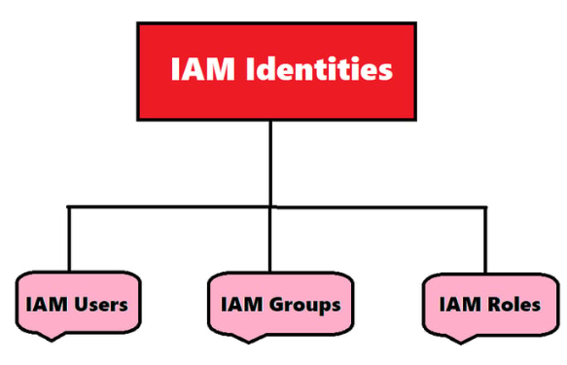
1. IAM Users:
An IAM User represents an individual person or service that interacts with AWS resources. Each user has unique credentials to access the AWS environment.
- Key Features:
  - Each IAM user can have a username and password for AWS Management Console access.
  - Users can also have access keys for programmatic access via AWS CLI, SDKs, or APIs.
  - IAM policies are attached to users to specify their permissions, defining what actions they can perform and on which resources.
- Use Cases:
  - Employees who need individual access to AWS resources.
  - Applications or services that require access to specific AWS functionalities.
- Best Practices:
  - Grant permissions based on the principle of least privilege.
  - Enable Multi-Factor Authentication (MFA) for enhanced security.
  - Rotate access keys regularly to minimize security risks.
2. IAM Groups:
An IAM Group is a collection of IAM users that share similar permissions. Groups simplify permission management by allowing you to assign policies to the group rather than managing permissions for each user individually.
- Key Features:
  - Groups do not have their own credentials; they exist solely for managing permissions.
  - Users inherit the permissions assigned to the group.
  - A user can belong to multiple groups, inheriting permissions from all groups they are a part of.
- Use Cases:
  - Assigning permissions to teams or departments, such as admins, developers, or finance teams.
  - Simplifying permission management by avoiding the need to attach policies to individual users.
- Best Practices:
  - Use descriptive names for groups (e.g., AdminGroup, DevOpsGroup).
  - Regularly review group memberships to ensure permissions align with current roles.
3. IAM Roles:
An IAM Role is an identity that AWS services or applications can assume to gain temporary access to AWS resources. Unlike users, roles do not have a long-term password or access keys.
- Key Features:
  - Roles use temporary security credentials to interact with AWS services.
  - IAM policies are attached to roles to define what actions the role can perform.
  - A trust policy is also attached to the role, specifying who or what can assume it (e.g., an AWS service, IAM user, or an external identity provider).
- Use Cases:
  - Granting cross-account access: Allowing users from one AWS account to access resources in another.
  - AWS service access: Allowing AWS services like Lambda or EC2 to access resources on your behalf.
  - Identity federation: Enabling external identity providers (e.g., Okta, Active Directory) to grant users access to AWS.
- Best Practices:
  - Use roles for applications or services instead of embedding access keys in code.
  - Rotate trust policies periodically to prevent unauthorized access.
  - Monitor role usage using AWS CloudTrail.
Roles:
IAM Roles are a set of permissions that grant temporary access to AWS actions and resources. Unlike IAM Users or Groups, roles are not tied to a single identity. They can be assumed by any trusted entity, such as users, applications, or services, using temporary security credentials.
Key Features of IAM Roles:
- Permission Attachment: Permissions are associated with the role itself, not with a user or group.
- Temporary Credentials: Roles generate temporary security credentials, avoiding the need for long-term credentials like passwords or keys.
- Shared Access: Roles can be assumed by multiple entities, making them reusable and ideal for various use cases.
- Cross-Account Usage: Roles can provide access to resources in the same account or in another AWS account.
- Delegation: Roles delegate access to resources for users, applications, or third parties.
Common Use Cases for IAM Roles:
- Access Within the Same AWS Account: Grant access to users or applications for specific resources.
- Cross-Account Access: Allow users from another AWS account to access resources in your account.
- Mobile App Access: Grant app access to AWS resources without embedding access keys.
- External Identities: Provide access to resources for identities outside of AWS (e.g., third-party providers).
- Third-Party Audits: Enable third-party entities to perform audits on your AWS resources.
Terms Associated with IAM Roles:
- Delegation:
Delegation is the process of granting permissions to users, allowing them to access resources owned by another account. It involves creating a trust relationship between the Trusted Account (owns resources) and the Trusting Account (contains users needing access). Trust relationships can exist within the same account, between accounts in the same organization, or between different organizations.
- Permission Policy:
A Permission Policy defines what actions a role, user, or group can perform on specific AWS resources. It specifies which services and resources can be accessed and what actions can be taken. These policies are written in JSON format and are used to grant the necessary permissions for tasks.
- Trust Policy:
A Trust Policy specifies which entities (e.g., users or roles) are allowed to assume a particular role in AWS. It is written in JSON format and determines who can use the role by defining trust relationships.
- Federation:
Federation allows users to access AWS resources using external credentials from identity providers like Facebook or Google. It creates trust between AWS and the external provider, enabling users to log in with their external credentials.
- Permissions Boundary:
A Permissions Boundary is an advanced feature that limits the maximum permissions a role or user can have. It acts as a boundary for permissions, ensuring the user or role does not exceed specified limits. It cannot be applied to service-linked roles.
- Principal:
A Principal is an entity that can assume a role, such as an IAM user, group, or another role. Permissions can be granted to a principal through permission policies or by specifying the principal in a resource-based policy.
- Cross-Account Access:
Cross-Account Access allows users or services in one AWS account to access resources in another account. It can be implemented using roles or resource-based policies, with policies attached directly to resources like S3, SNS, or SQS.
Creating IAM Roles:
Step 1: Login using Root user
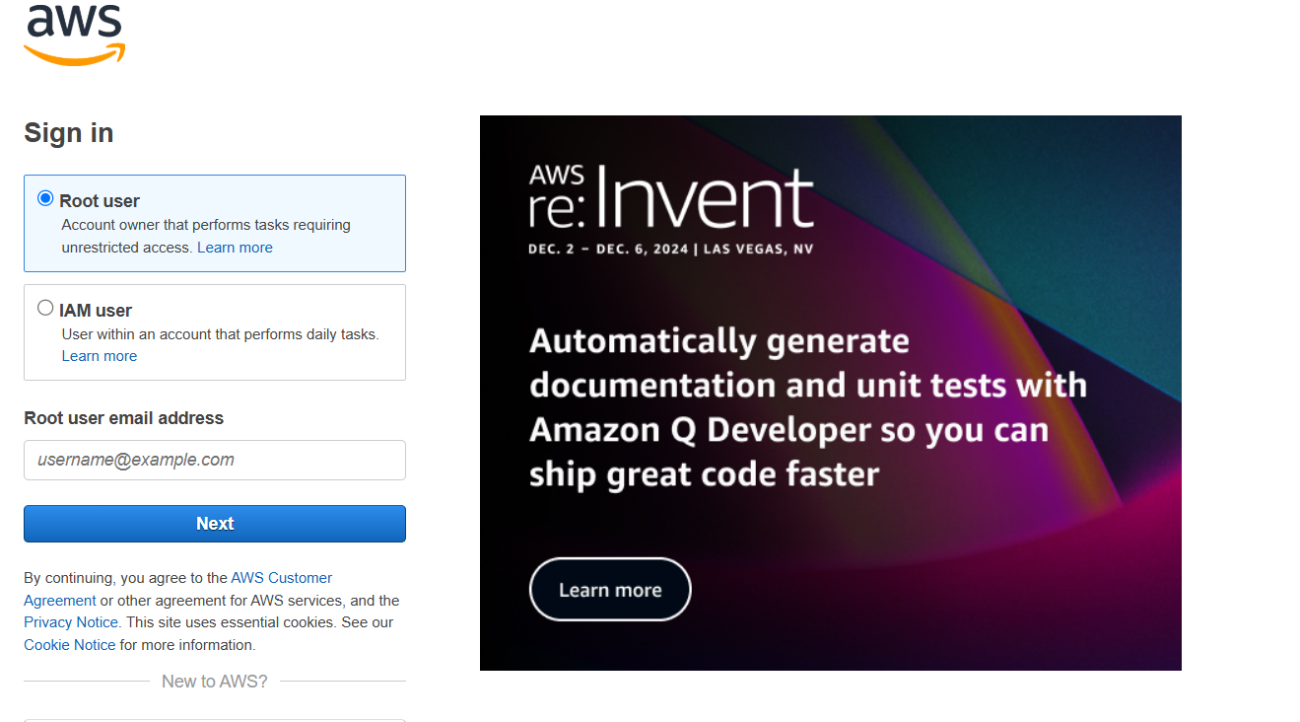
Step 2: Now, go to All Services and select IAM
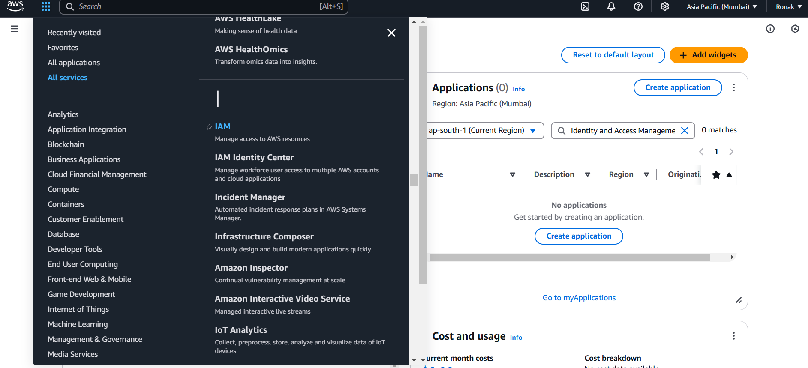
Step 3: Now, this dashboard will appear of IAM
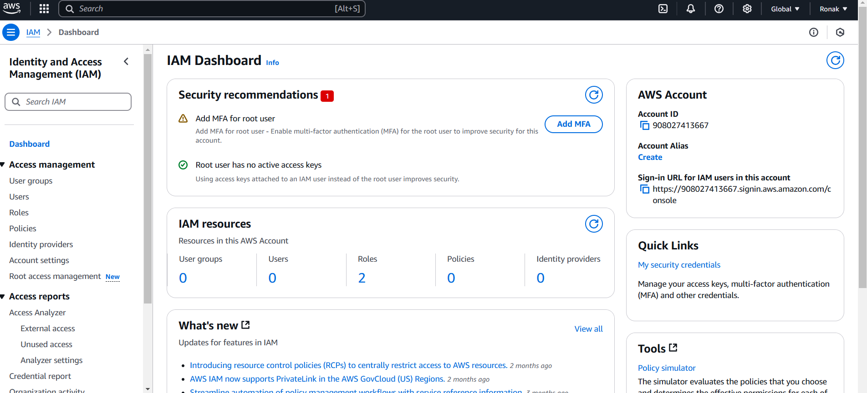
Step 4: Now, go to Users
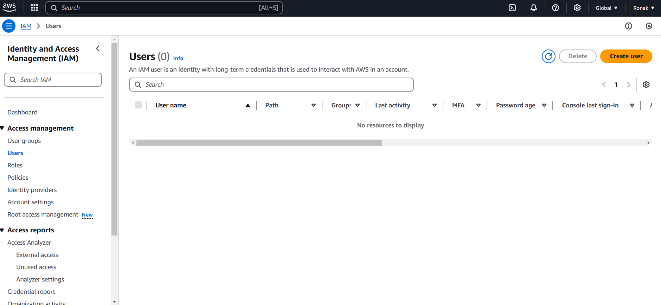
Step 5: From the top-right option of Create User, click on that and add Details
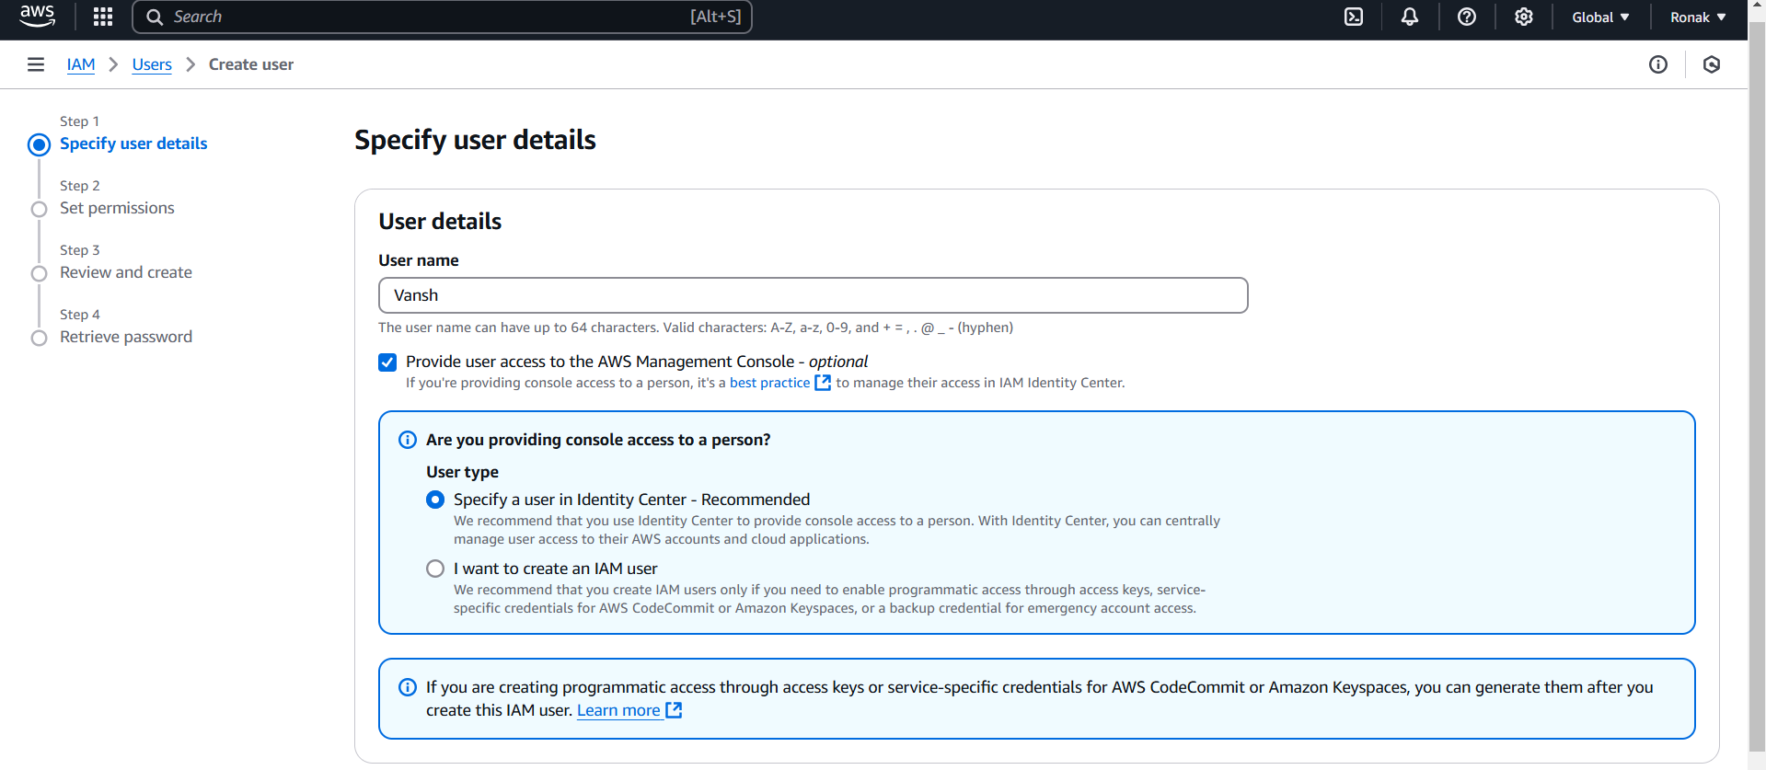
Step 6: Now, set permissions
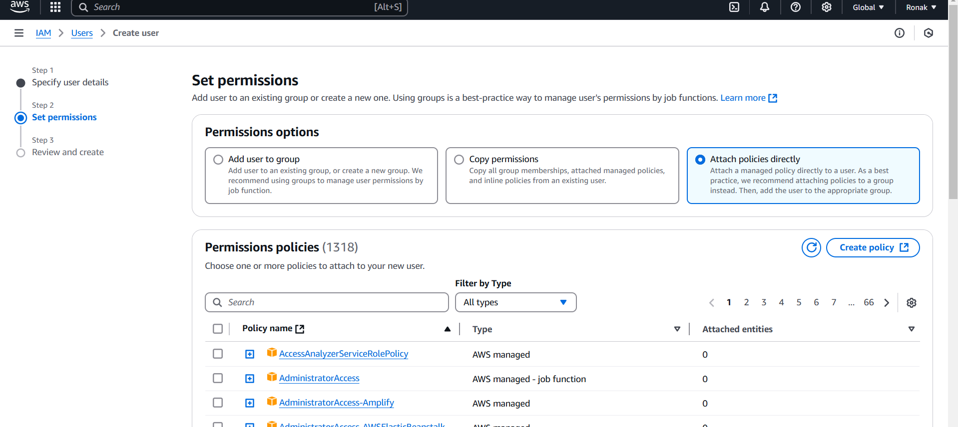
Step 7: Now, click on Create User after which it will appear on the Users list.
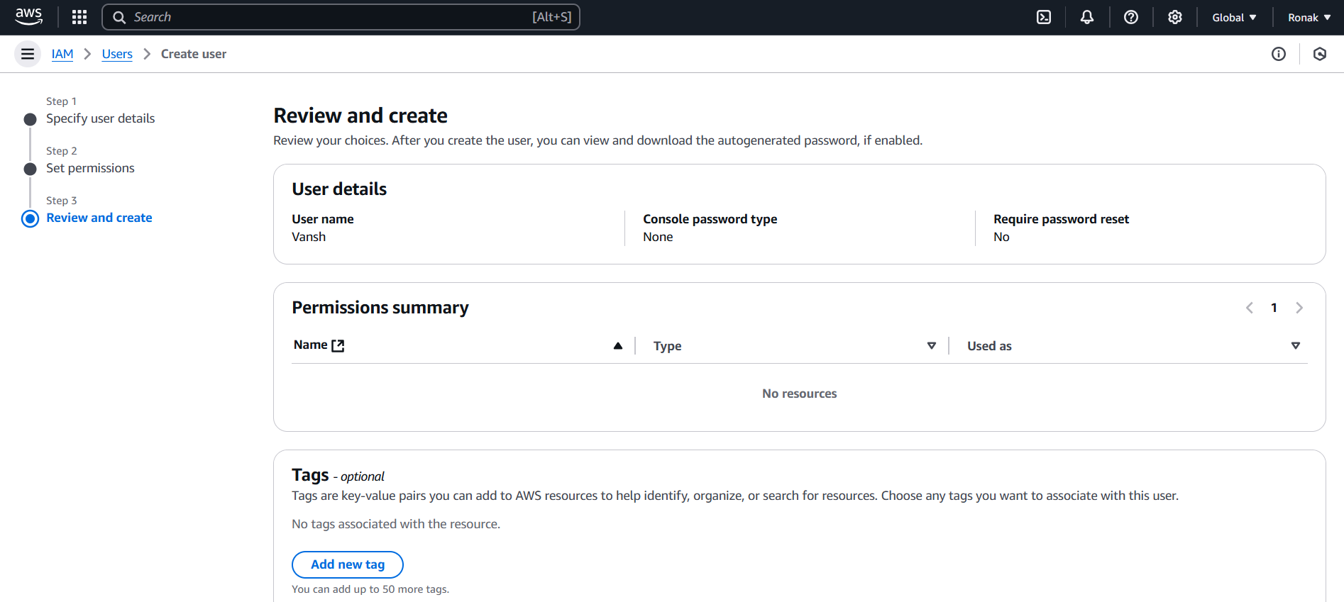
OR
You can also add Permissions in previous step also like for this user
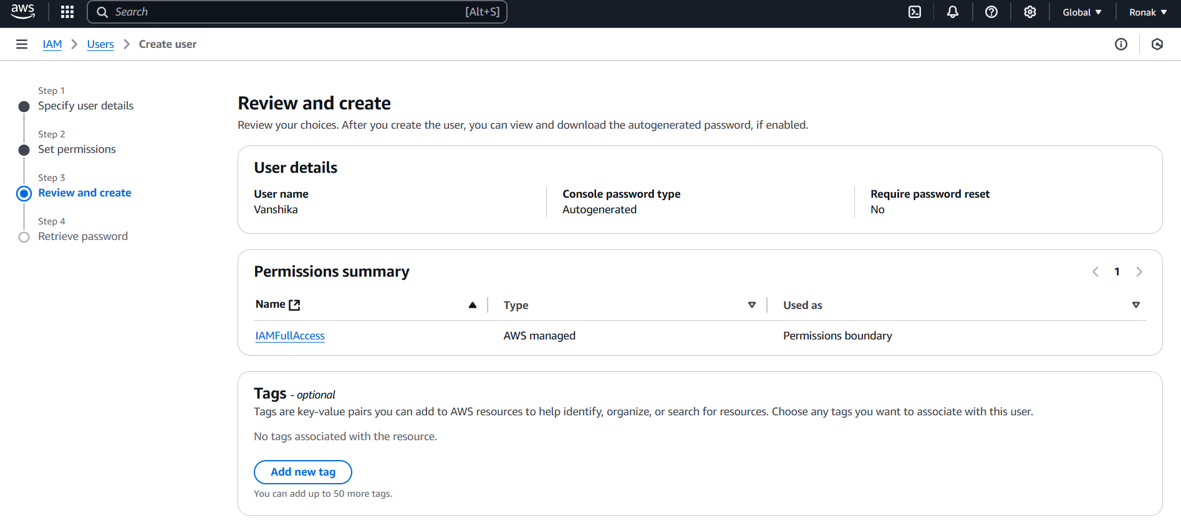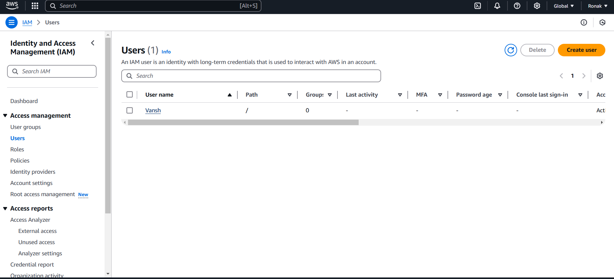
Step 8: Now, to set the permissions go to Users and set permission boundary and Permission Policies
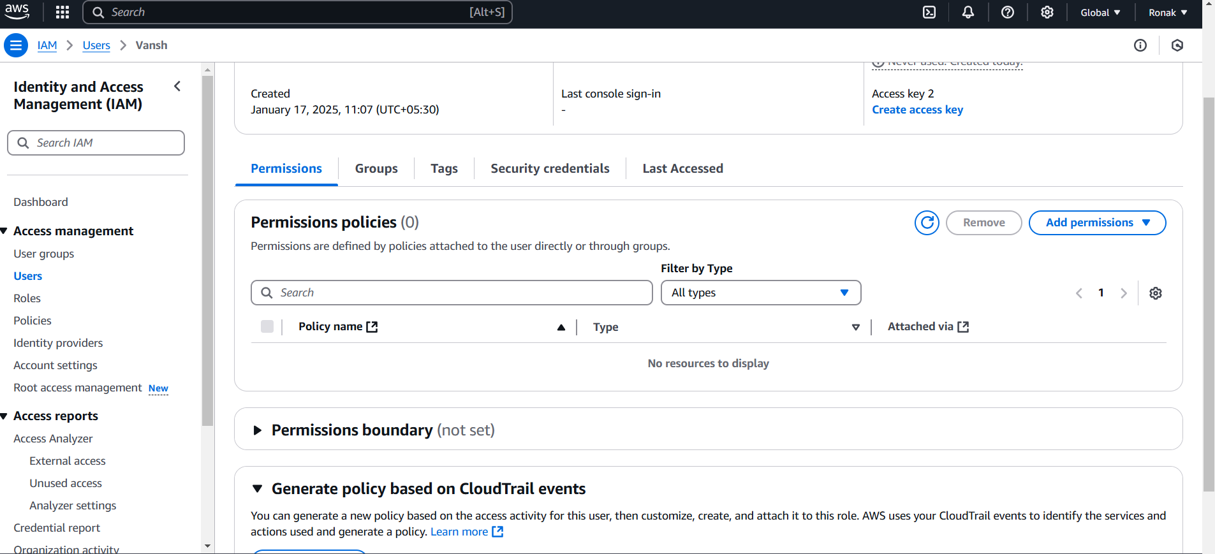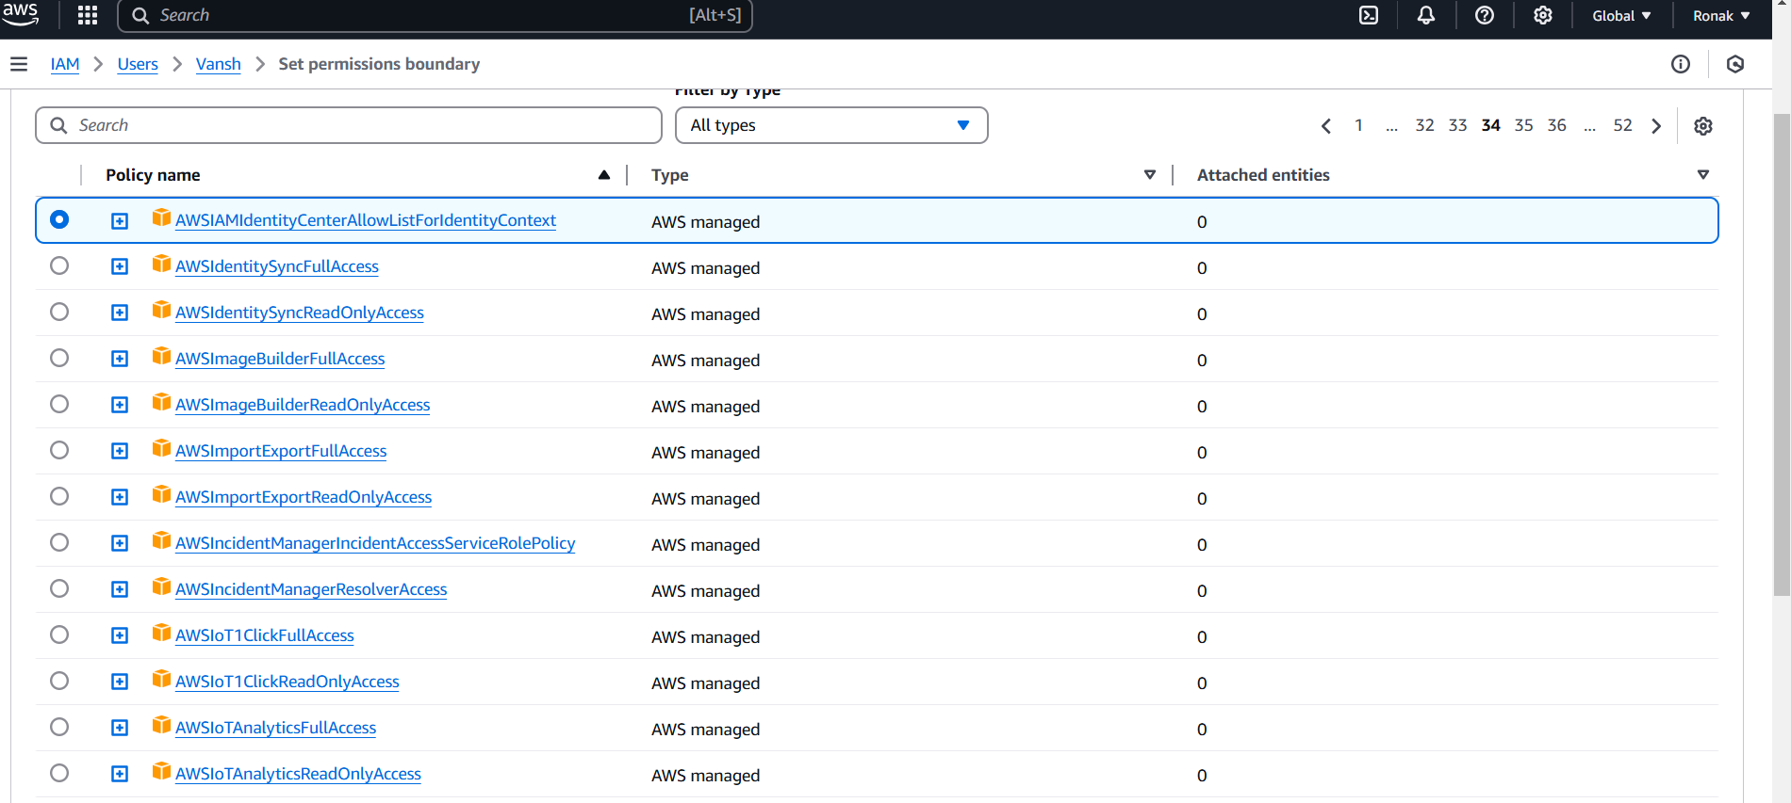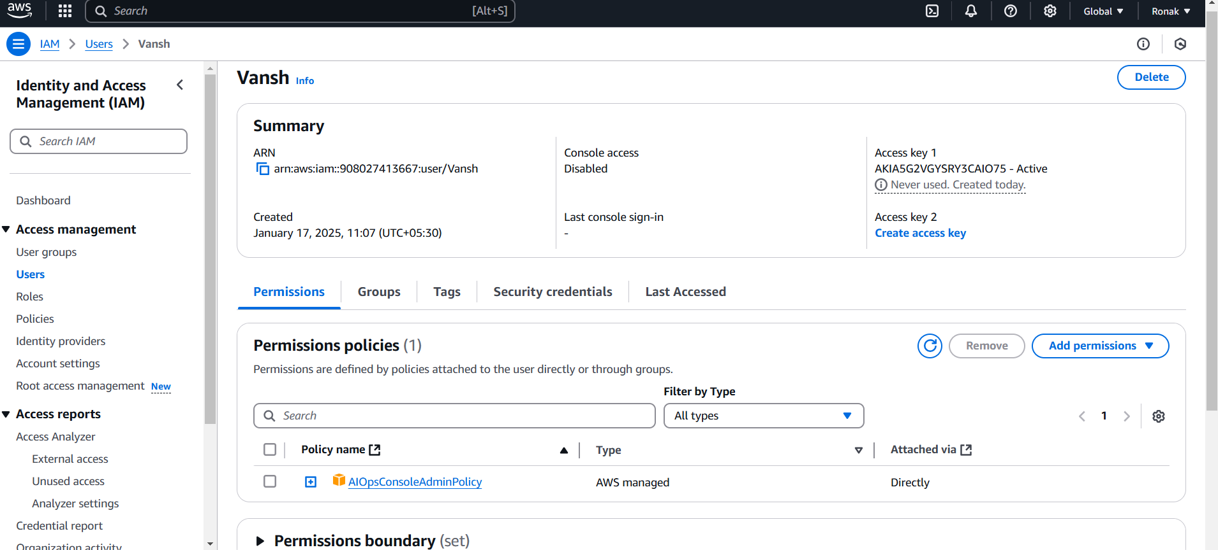
Step 9: Now, go to Security Credentials and create Console Password and save it as you are going to access by AWS Console only
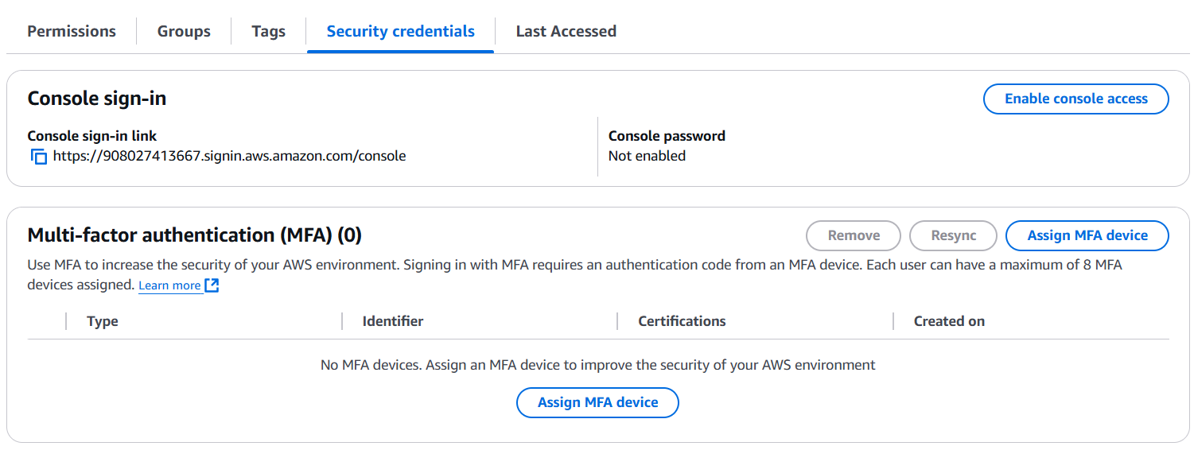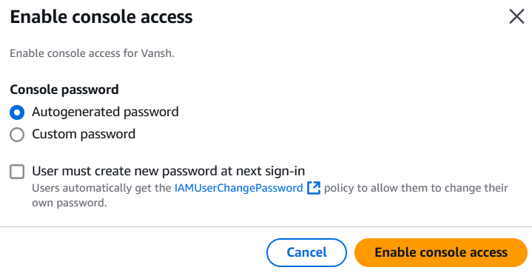
Step 10: Now, an IAM User is generated and you can save the following credentials at your end and share as per your need.
